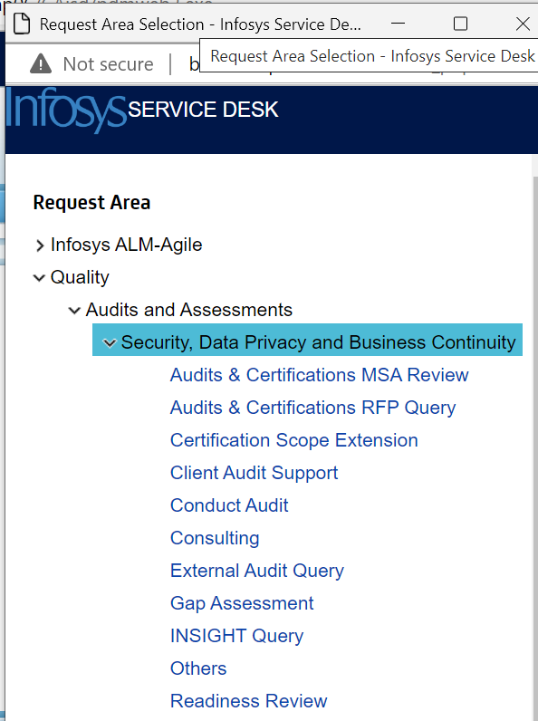

Level | Rate card
JL3 | 20Euros
JL4 | 40 Euros
JL5 | 80 Euros
JL6 | 150 Euros

